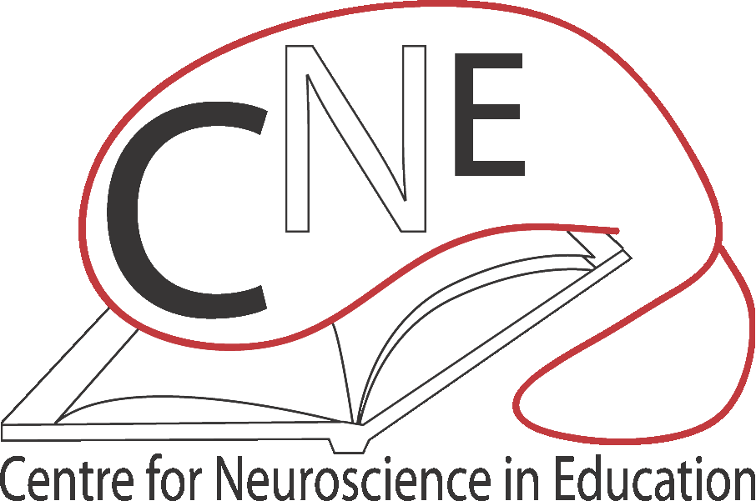

Participant Information Sheet

Language and Rhythm in Children 2020

Before you and your child decide whether to take part in this study it is important for you to understand why the research is being done and what it will involve. Please take time to read the following information carefully and discuss it with others if you wish. You can contact a member of the team if there is anything that is not clear or if you would like more information. Take time to decide whether or not you wish to take part.

Purpose of the study

We want to find out whether individual differences in perceiving rhythm in language are related to children’s overall language development. To do this, we want to understand how children listen to rhythm both in language and in non-speech sounds, and how their brain responds.

Why have I been chosen?
Your child has been asked to take part because we would like to find out about the listening skills of primary school children who have a range of different language abilities.

Does my child have to take part?

No, participation is entirely voluntary and there are no consequences if you or your child decides not to take part.

What will happen to my child if they take part?

There are 3 aspects to the study:

- We will measure your child’s listening skills to rhythmic and other sounds, in short sessions given during the school day, lasting no more than 20 – 30 minutes on any one day. We will also measure language and reading skills, memory and attention. These skills will be measured twice, at least 18 months apart. If there are future lock-downs affecting the timing of these assessments, we will try and measure these skills remotely via Zoom.
- We will measure how your child’s brain responds to language rhythm using EEG (see below for an explanation). This will involve a single visit to the Centre for Neuroscience in Education in Cambridge during the school holidays or at the weekend. You do not have to take part in this section of the study – we will ask you later if you would like to be involved.
- We will record how your child’s brain responds to language rhythm using MEG (see below for an explanation). This will involve a single visit to the MRC Cognition and Brain Sciences Unit in Cambridge during the school holidays or at the weekend. You do not have to take part in this section of the study – we will ask you later if you would like to be involved.

EEG
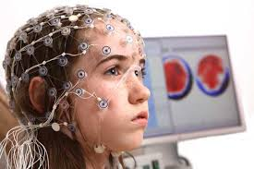
EEG is a method of imaging the brain which is painless and
non-invasive. If they take part in the EEG study, your child will wear a net of sensors on their head like the one in the picture opposite. You cannot feel the net on your head once it is on. The net measures the tiny amount of electrical activity that the brain generates when it senses something happening (e.g. hears a sound). These electrical patterns, or 'brainwaves', tell us how the brain processes sounds. The EEG study will take about 2 hours in total and you and your child will need to come to the Centre for Neuroscience in Education, Department of Psychology, University of Cambridge, Downing Street, Cambridge, CB2 3EB
EEG Sensor Net

MEG
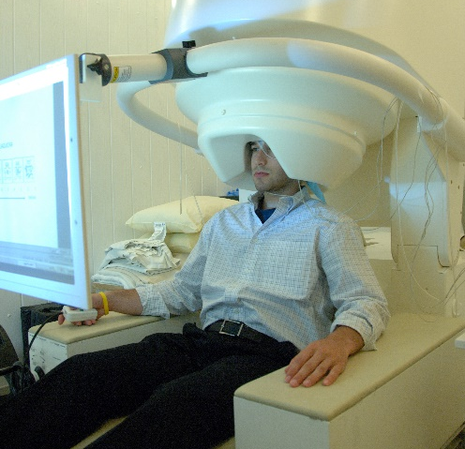
An MEG recorder
MEG is another type of brain imaging. MEG measures the changes in magnetic fields in the brain while sounds are heard. These magnetic fields are tiny, they are one billion times smaller than the magnetic field generated by the electricity in a lightbulb. The measurement of brain activity takes place while the child listens to a story or hears rhythmic sounds. The MEG measurement involves sitting in a magnetically shielded room. The sensors measuring the magnetic activity are inside a kind of “helmet” that lightly touches the head. When we make the recording, your child will sit on a comfy chair. They will not be able to feel the machine. To make the most of the information from the MEG recording, we will also use an MRI scan to take a picture of your child’s brain. The MEG study will take about 2 hours in total and you and your child will need to come to the MRC Cognition and Brain Science Unit, Chaucer Road, Cambridge, CB2 7EF

Are there possible disadvantages and/or risks in taking part?
No. The activity sessions in school will be like other school activities. EEG and MEG are completely painless and non-invasive. The EEG sensor net needs to be damp. Because of this, your child’s hair may get a bit damp. There will be towels, hairdryers and clean-up facilities for when the EEG is finished. The MEG measurement is also completely painless and non-invasive. Note that you should not have MEG measurements if you are fitted with a cardiac pacemaker or you have iron pins or other ferrous materials in your head (dental fillings are okay). This is because ferrous materials produce excessive noise in MEG recordings, not because ferrous materials cause risk to your child. Sometimes children find it uncomfortable to sit still while the EEG and MEG are recorded. There are regular pauses during the recordings (every 3-4 minutes). Your child can rest during the pauses if you or they feel they need to. The EEG and MEG recordings should each last about an hour. We ask you to allow 2 hours for the visit to give time for setting up the sensor net and for cleaning up afterwards.

The MRI recording is also painless, but your child will have to lie inside the scanner (a sort of tube) while a picture of their brain is generated. Your child can communicate with the person doing the scanning at all times via intercom, and can request to come out again at any time. The scan takes about half an hour and the machine is noisy, however noise-cancelling headphones are provided and distracting music can be played through these headphones.

What are the possible benefits of taking part?
Your child will not benefit directly from taking part, but we hope to use the information from the study to help improve the educational development and quality of life for children in the future through the development of specialised training programmes.

Will my taking part in this project be kept confidential?
All data will only be identified by a code. We will keep any personal details in a locked file or secure computer which only the immediate research team can access. You can find general information about how the University uses personal information at: https://www.information-compliance.admin.cam.ac.uk/data-protection/research-participant-data

What will happen to the results of the research project?
Results will be presented at conferences and written up in academic journals. Results are normally presented in terms of groups of individuals. If any individual data are presented, the data will be totally anonymous, so that no individuals can be identified. Data collected during the course of the project might be used for additional or subsequent research.

Who is organising and funding the research?
The Study is organised by the Centre for Neuroscience in Education at the University of Cambridge and funded by the Yidan Foundation.
Ethical review of the study
The project has been reviewed by the Psychology Research Ethics Committee of the University of Cambridge.

Contact for further information
If you have any complaints about the way in which this research project has been, or is being, carried out, then please get in touch with Dr Susan Richards sr486@cam.ac.uk

If your problems are not resolved, or you wish to comment in any other way, please contact Professor Goswami (ucg10@cam.ac.uk) at the Department of Psychology, Downing Street, Cambridge.

If you are happy for your child to take part, please click to complete the consent form:

Consent Form Listening to Language and Rhythm in Children

Thank you for your time and interest!

